# Setting up the cluster

Write an email to helpdesk@cai.uq.edu.au and ask for your uq-username to be added  
to the CAI Linux LDAP user group (cai-logon group)

# Connecting and setting up the cluster for freesurfer/FSL usage

Use the following command to go to the cluster environment:

ssh -p 2200 [username]@cai-zlock.cai.uq.edu.au

Use the following command to link the “master” profile to your personal profile:

ln -s .bashrc .bash_profile

Then you need to modify the .bashrc profile to add some lines to it. The purpose is to add useful batch files to the commands you may use. To edit use:

vi .bashrc

This will show you the content of the .bashrc file. We are going to add the following lines to it:

export PATH=$PATH:/data/lfs2/software/ubuntu14/script_bin

export FREESURFER_HOME=/data/lfs2/software/ubuntu14/freesurferv6-2017-03-08

source $FREESURFER_HOME/SetUpFreeSurfer.sh

For FSL, also add the followings:

FSLDIR=/usr/share/fsl/5.0/

. ${FSLDIR}/etc/fslconf/fsl.sh

PATH=${FSLDIR}/bin:${PATH}

export FSLDIR PATH

To do so, in the “vi” environment, use the arrow keys to go down. At the very end, hit a character (“s” for example). Down the page you will see a white “Insert”.

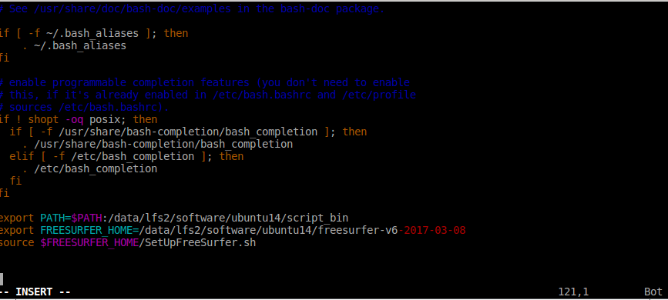

Then copy the texts above and put them at the end of the file (it should look like the above figure).

Hit “Esc” to exit the “insert” mode. Type “:w” and hit enter (it will save the .bashrc). Type “:q” and hit enter. It will exit. Now exit the cluster (type “exit”) and ssh again (to go to the cluster environment). You should see the following settings come up automatically.

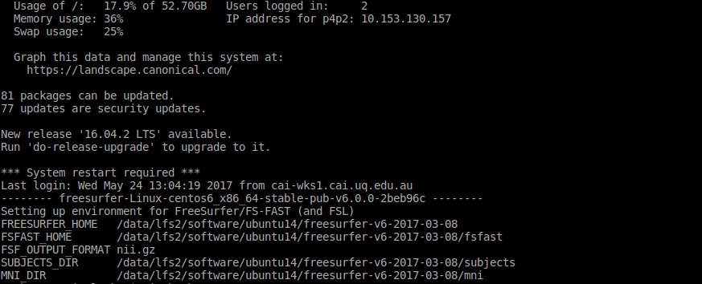

This means that the freesurfer (for FSL, there will be one more line to this) has been setup for your profile in the cluster.

# Folders structure

Lets say we have two participants, 14 and 15. The program expects to have the following structure for the raw data. Note that the Results folder and all of its subfolders are generated by the program automatically.

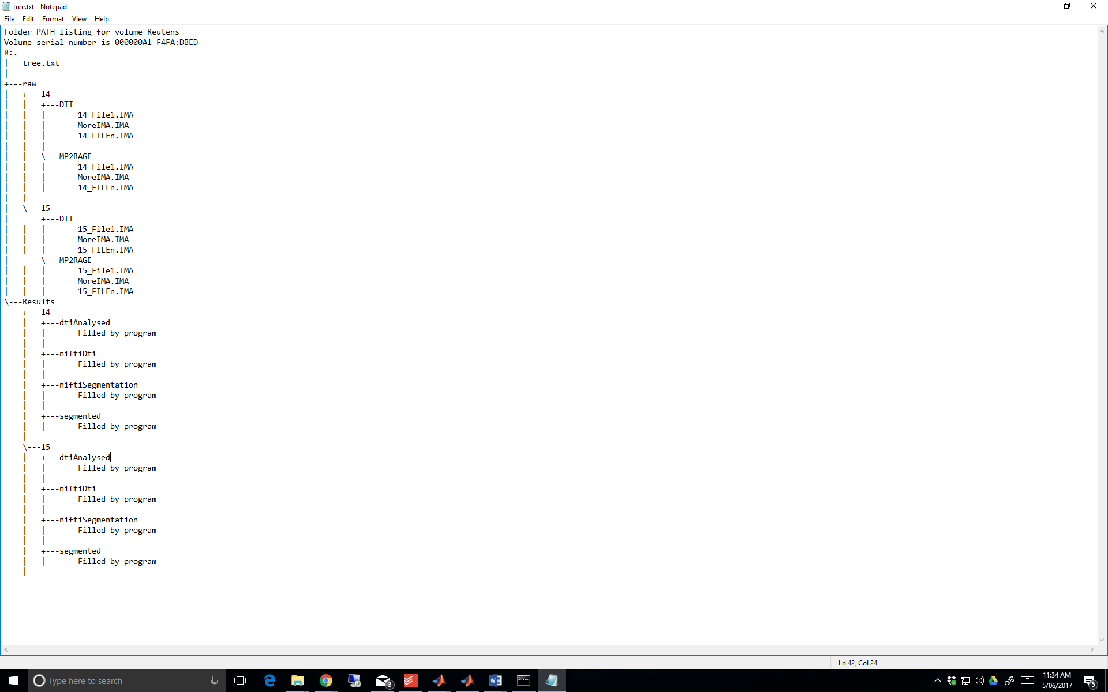

The program assumes that under “rootDir”, there is a directory “raw” and under that there are participants, under each a folder for DTI and a folder for structural (the folder names specified in variables struc.folder and dti.folder).

# Running the code

First set up all the addresses:

If you need cluster, use the above procedures to set that up.

Specify the address for the raw mri data, structural folder names, where to save the niftis (for DTI and Segmentation) and where to save the segmentations. If you need cluster, you also need to specify a temporary address where to save the raw data as dumu does not work properly with the cluster.

After setting up, chose if you want it to run on the cai cluster or the local machine. Run the code. It will generate a command on the matlab command line. Copy that and paste it in a terminal. If it is under cluster, when you paste it, the terminal asks for your password (cluster password), type that in and the following would appear:

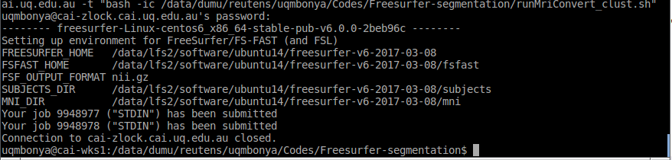

That means it has started running those jobs. All good.

If you want to check the status of your jubs, login to the cluster (ssh –p 2200 [username@cai-zlock.cai.uq.edu.au](mailto:username@cai-zlock.cai.uq.edu.au)) and type “qstat -u USERNAME”.

If it is not running on a cluster then the terminal does not ask any question and gets to the analyses.